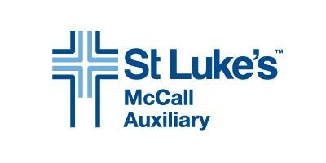

MARGARET FOGG MEMORIAL SCHOLARSHIP

GUIDELINES FOR HIGH SCHOOL SENIORS

Due Date for Application: April 26, 2024
Applications must be submitted digitally, in pdf format, to: morganka@slhs.org

Please include the following information in this order:

- Name, mailing address, telephone number and e-mail address.
- High school transcript with unweighted GPA.
- List of all science and health care related courses.
- Work experience and/or volunteer service related to health care field.
- School and community activities - include leadership roles, awards/recognition received and other work and/or volunteer activities
- Essay describing why you are pursuing a career in the health care field, your passions and what challenges you foresee, not to exceed 700 words.
- Two current letters of reference – one must be from a health care professional.
- Other educational funding sources i.e., known scholarships, grants etc.

All application materials must be submitted digitally, in pdf format, to: morganka@slhs.org

All applicants will be notified of the selection committee’s final decision
with respect to their application.

For questions, please call or e-mail:
Pam Davis
208-315-4938
padavis579@gmail.com

The Margaret Fogg Memorial Scholarship serves students from St. Luke’s McCall service area encompassing Valley County, Adams County and north to Riggins.

