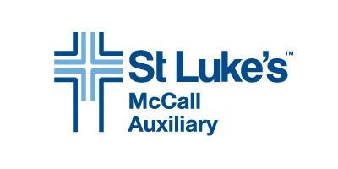
MARGARET FOGG MEMORIAL SCHOLARSHIP
GUIDELINES FOR POST SECONDARY APPLICANTS

Due Date for Application: April 26, 2024
Applications must be submitted digitally, in pdf format, to: morganka@slhs.org

Please include the following information in this order:

- Name, mailing address, telephone number and e-mail address.
- School you plan to attend, degree or certification desired, full time or part time attendance and formal acceptance into health care program.
- List in chronological order all schools attended, beginning with high school and degrees granted.
- Transcript from current or most recent educational institution, including class rank, e.g.
freshman, sophomore etc.
- List of all science and health care related courses taken.
- Work experience and/or volunteer service related to the health care field, including whether you are currently working in health care, and in what capacity.
- An essay including your educational and professional goals in the health care field, your passions and the challenges you foresee in your educational pursuits, not to exceed 700 words.
- Please list all scholarships, stipends, tuition reimbursement or other educational financial support you are receiving for this application year.
- Two current letters of reference – one must be from a health care professional

All application materials must be submitted digitally, in pdf format, to: morganka@slhs.org

All applicants will be notified of the selection committee’s final decision with respect to their application.

For questions please call or e-mail:
Pam Davis
208-315-4938
padavis579@gmail.com

The Margaret Fogg Memorial Scholarship serves students from St. Luke’s McCall service area encompassing
Valley County, Adams County and north to Riggins.

