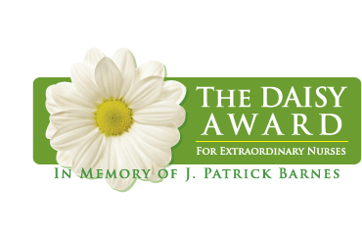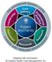

DAISY AWARD FOR EXTRAORDINARY CAREGIVERS

The Daisy Award recognizes our extraordinary caregivers for the care and compassion they exhibit every day in caring for our patients.

I would like to nominate __________________________________, RN/LPN, as a deserving recipient of the Daisy Award. This RN/LPN exemplifies the kind of nurse that patients and families recognize as making a difference in their stay at St. Luke’s.
Demonstrating Relationship-based Care, the clinical professional practice model at St. Luke’s, this RN/ LPN exhibits care and compassion in the following ways:
- Makes a special connection with patients/ families
- Includes patients and families in the planning of their care
- Does an excellent job educating patient and family for next level of care
- Works well with the healthcare team to meet patient and family need
- Listens to patients and families and makes them feel comfortable
- Goes above and beyond what is needed for the situation

The following describes why I believe _______________________________, RN/LPN is a deserving recipient of the Daisy Award:
______________________________________________________________________________
______________________________________________________________________________
______________________________________________________________________________
______________________________________________________________________________
______________________________________________________________________________
______________________________________________________________________________
______________________________________________________________________________
______________________________________________________________________________

Submitted by: ________________________________E-mail________________ Phone: ____________________
Patient Visitor/ Family Peer Volunteer Physician Other: ______________________

Email form to the Center for Nursing Excellence, Attention Robyn Beall at DAISYnominations@slhs.org

